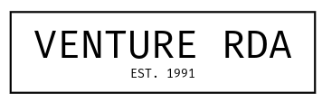
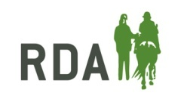

Pony Adoption Form
I would like to adopt (please tick) - £50 per pony:

Hal

Jasper

Peter

Misty

Full name of person making payment: ....................................................................................................
Address: ...................................................................................................................................................
........................................................................................... Postcode: .....................................................
Contact email address: ............................................................................................................................
Contact telephone number: ....................................................................................................................

If your adoption is for a friend or family member, please complete their details below.
Name of recipient: ...................................................................................................................................
Address of recipient: ................................................................................................................................
........................................................................................... Postcode: .....................................................

Total amount of £........... paid by (please tick):
PayPal via Website ‘Donate’ page
Cheque payable to Venture RDA
Electronically via Internet Banking
Account Name: Wilby Riding for the Disabled
Sort Code: 53 61 33
Account no: 66142714

Please email completed form to venturerda@gmail.com and we will ensure that your application is processed as soon as payment is received. Your Pony Adoption Package will then be sent out via post. If you have any special requests, e.g. the Pony Adoption Package being sent by a specific date, please do let us know and we will try our best to accommodate.

